Team name: Project4

Scrum Master: Marc

Date:11 April 2019

|  |  |  |  |
| --- | --- | --- | --- |
| **Team Member** | **What did you do since the last scrum?** | **What do you plan to do before the next scrum?** | **What obstacles do you have?** |
| Jeffrey | Make it so user can login and logout  Connect to API | Populate profile page  -Tests | Running all tests  other classes |
| Marc | Started Unit Testing | More Unit Testing | Unit testing  Finding enough time. |
| Jazlyn | Updated Documentation  CSS | -Make sample games show up with EJS  -Change css | Finding enough time |
| Brandon | Working on DB structure X5 | Populating DB  -connecting DB to server | Other classes |

Burndown:

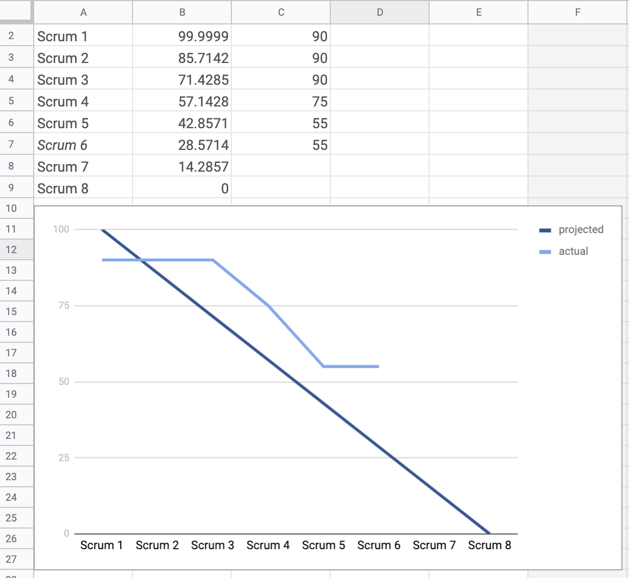

Screenshot of y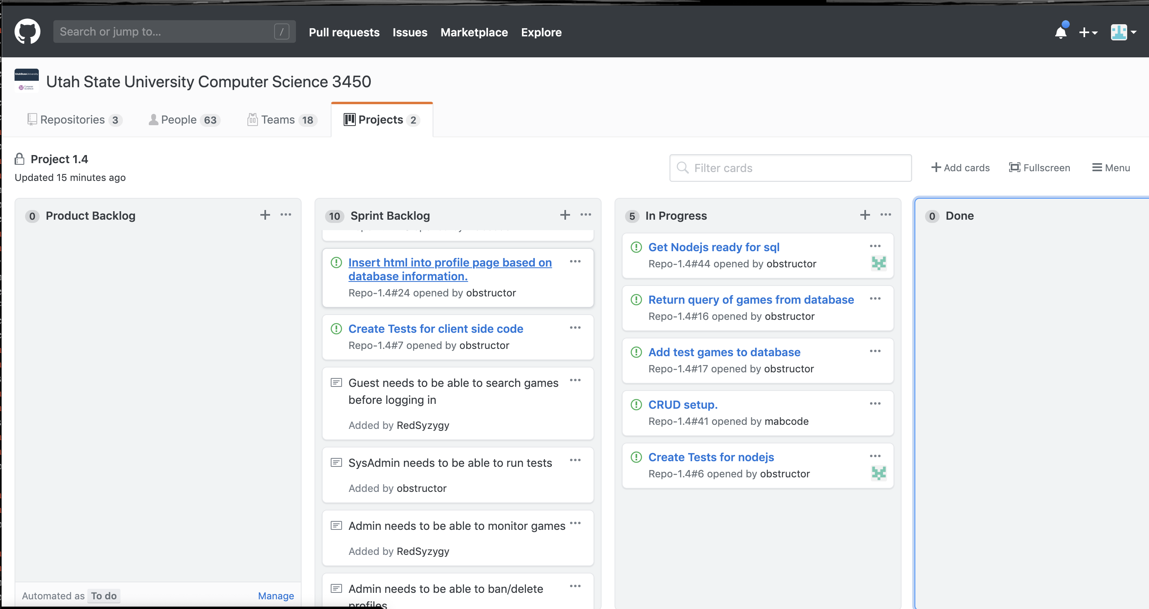our task board: